Question 2
I plugged in integers ranging from -12 to 12, showing that the factorial function that I wrote works. I also included the factorial of 13 to show that for values bigger than 12, the Assembly language does not calculate the correct factorial. This is because the factorial of 13 is:
13! = 6227020800
And 13!-2^32 = 1932053504
Which is what we get if we try to calculate the factorial of 13.
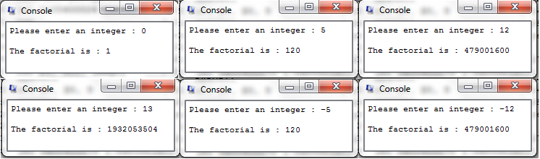

Question 3
I plugged in random arrays with different lengths and signs and the following are the results.
